Student’s name | …………………………………………………….…… | Grade | 2
Subject | Computer | Week No. | 8
Lesson Title | Computer Peripherals | Unit
Worksheet No. ( 8 ) (Answer)

write the correct name of each part.
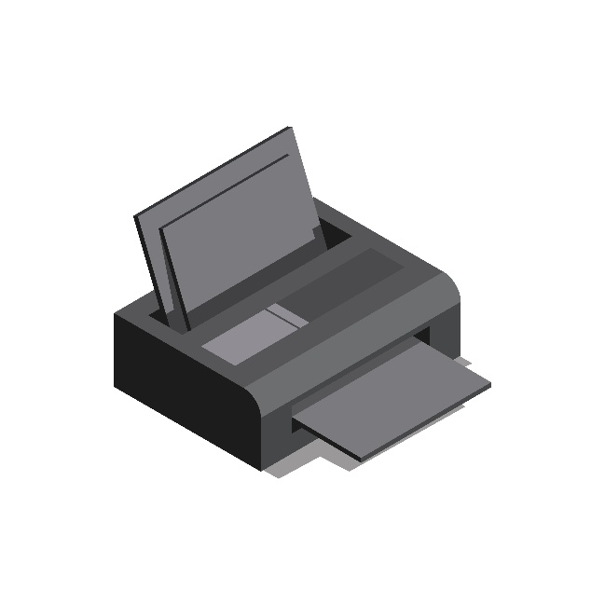
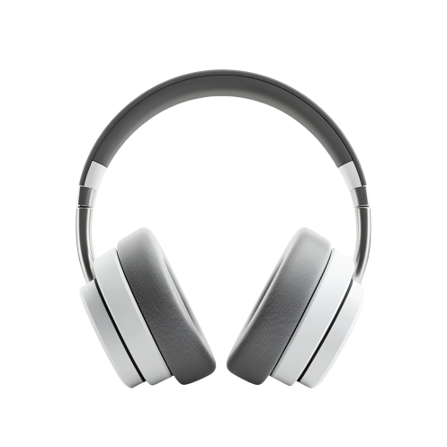
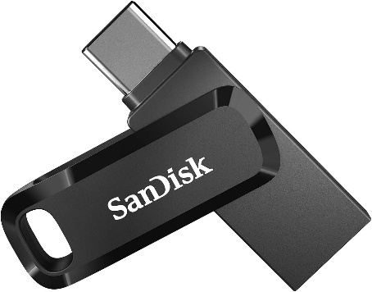
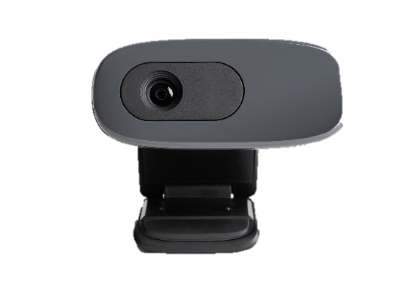
Scanner
Flash Drive
Webcam
Headphone
C: Drive
Headphone
Flash Drive
Webcam
Scanner
Good Luck

